Section A: Vector Databases

A1. What is a vector database?
1) A vector database stores data in the form of vectors (numbers) and helps us find similar data based on meaning. For example, a sentence can be converted into a vector using an embedding model. Later, we can compare that vector with other vectors to find similar information.
2) Traditional databases like MySQL or PostgreSQL mainly store structured data and are commonly used for exact searches. Vector databases are mainly used for similarity searches, which makes them useful in applications like RAG and semantic search.

A2. From raw text to a vector database
Suppose our sentence is:
«"Machine learning learns patterns from data."»
The basic steps are:
1. Raw text :– We start with the original sentence.
2. Pre-processing :– Clean the text if required.
3. Chunking: – Large documents are divided into smaller parts.
4. Embedding :– An embedding model converts the text into numbers (vector).
5. Storage :– The vector, original text, and metadata(data about data) are stored in the vector database.

A3. Why can't we use a B-tree for embeddings?
A B-tree is mainly useful for exact or range-based searches, such as finding a particular ID. Embeddings are different because we usually don't need an exact match. We want to find the vectors that are most similar to our query.
For example:
- B-tree: "Find student ID 101."
- Vector search: "Find documents most similar to this question."
Similarity can be calculated using methods such as cosine similarity. Therefore, normal B-tree indexes are not designed for this type of high-dimensional similarity search.

A4. Cosine similarity
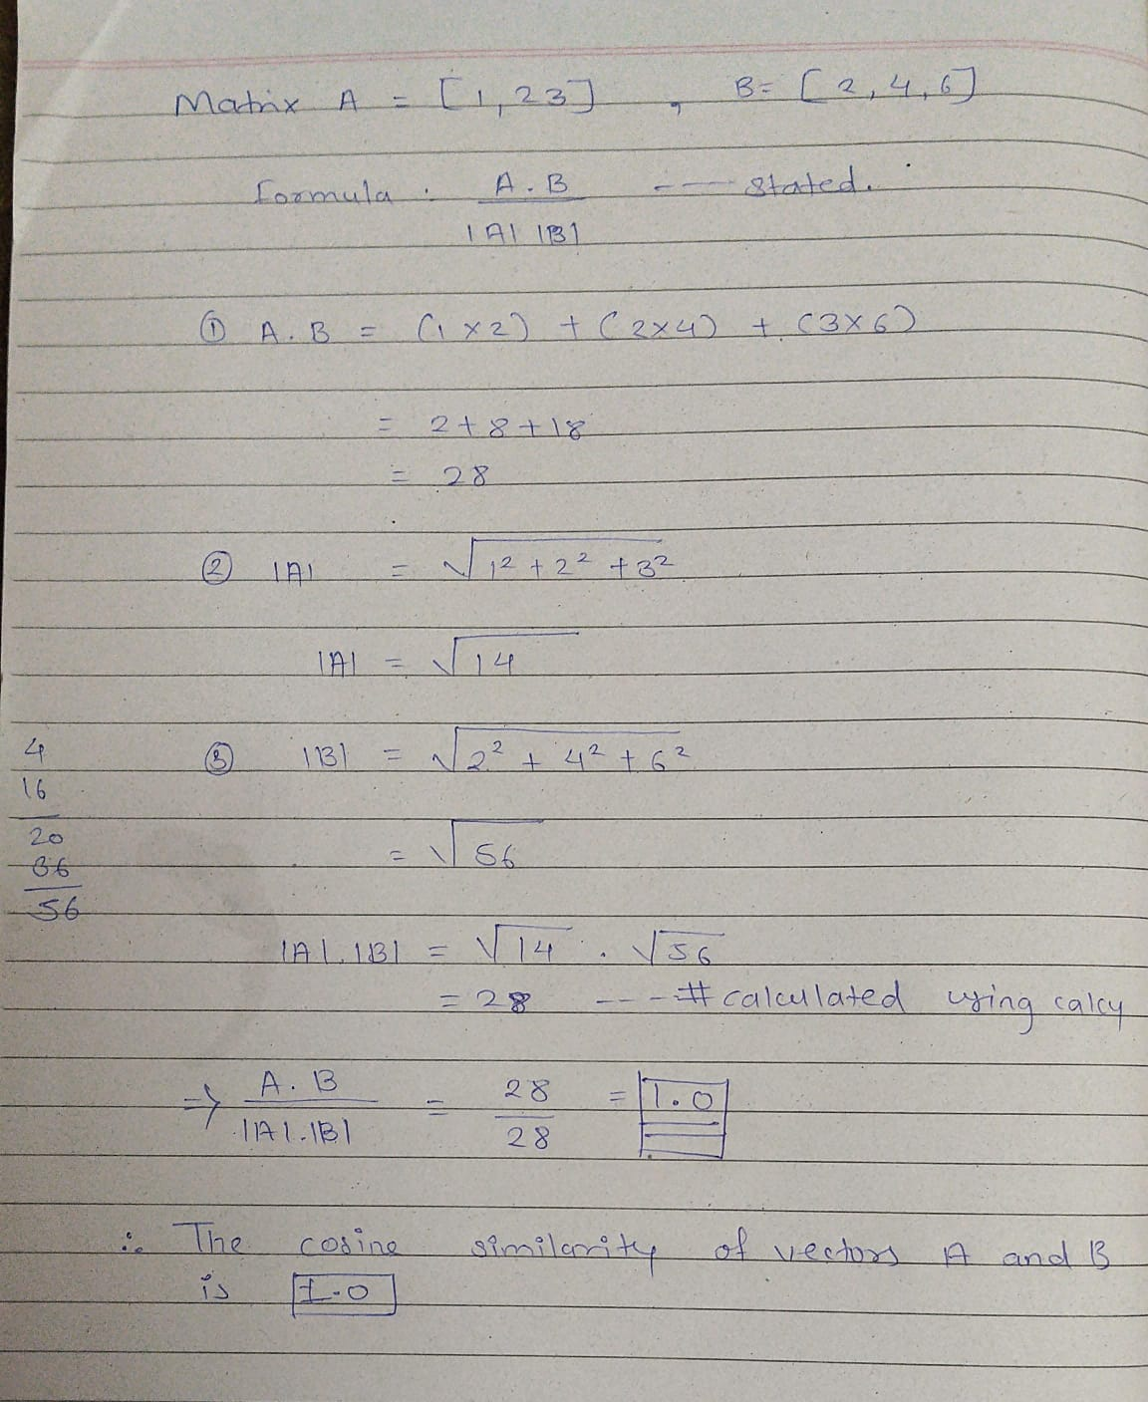
This means the two vectors point in exactly the same direction, so they are perfectly similar in terms of cosine similarity.

A5. Why is a vector database important for RAG?
In RAG, documents are converted into embeddings and stored in a vector database. When a user asks a question, the question is also converted into an embedding. The vector database then finds the most relevant document chunks using similarity search. The basic flow is:
Documents Embeddings Vector Database User Query Similarity Search Relevant Context LLM
If we remove the vector database/retrieval layer, the system may not be able to efficiently find the relevant information from the documents. This can result in irrelevant or incomplete context being given to the LLM.

